Assignment: ES6 Modern JavaScript

Scott Freedman

Ira A. Fulton Schools of Engineering, Arizona State University

IFT 458: Middleware Programming & Database Security

Professor Dinesh Sthapit

February 5, 2023

*Screenshot with terminal output:*

*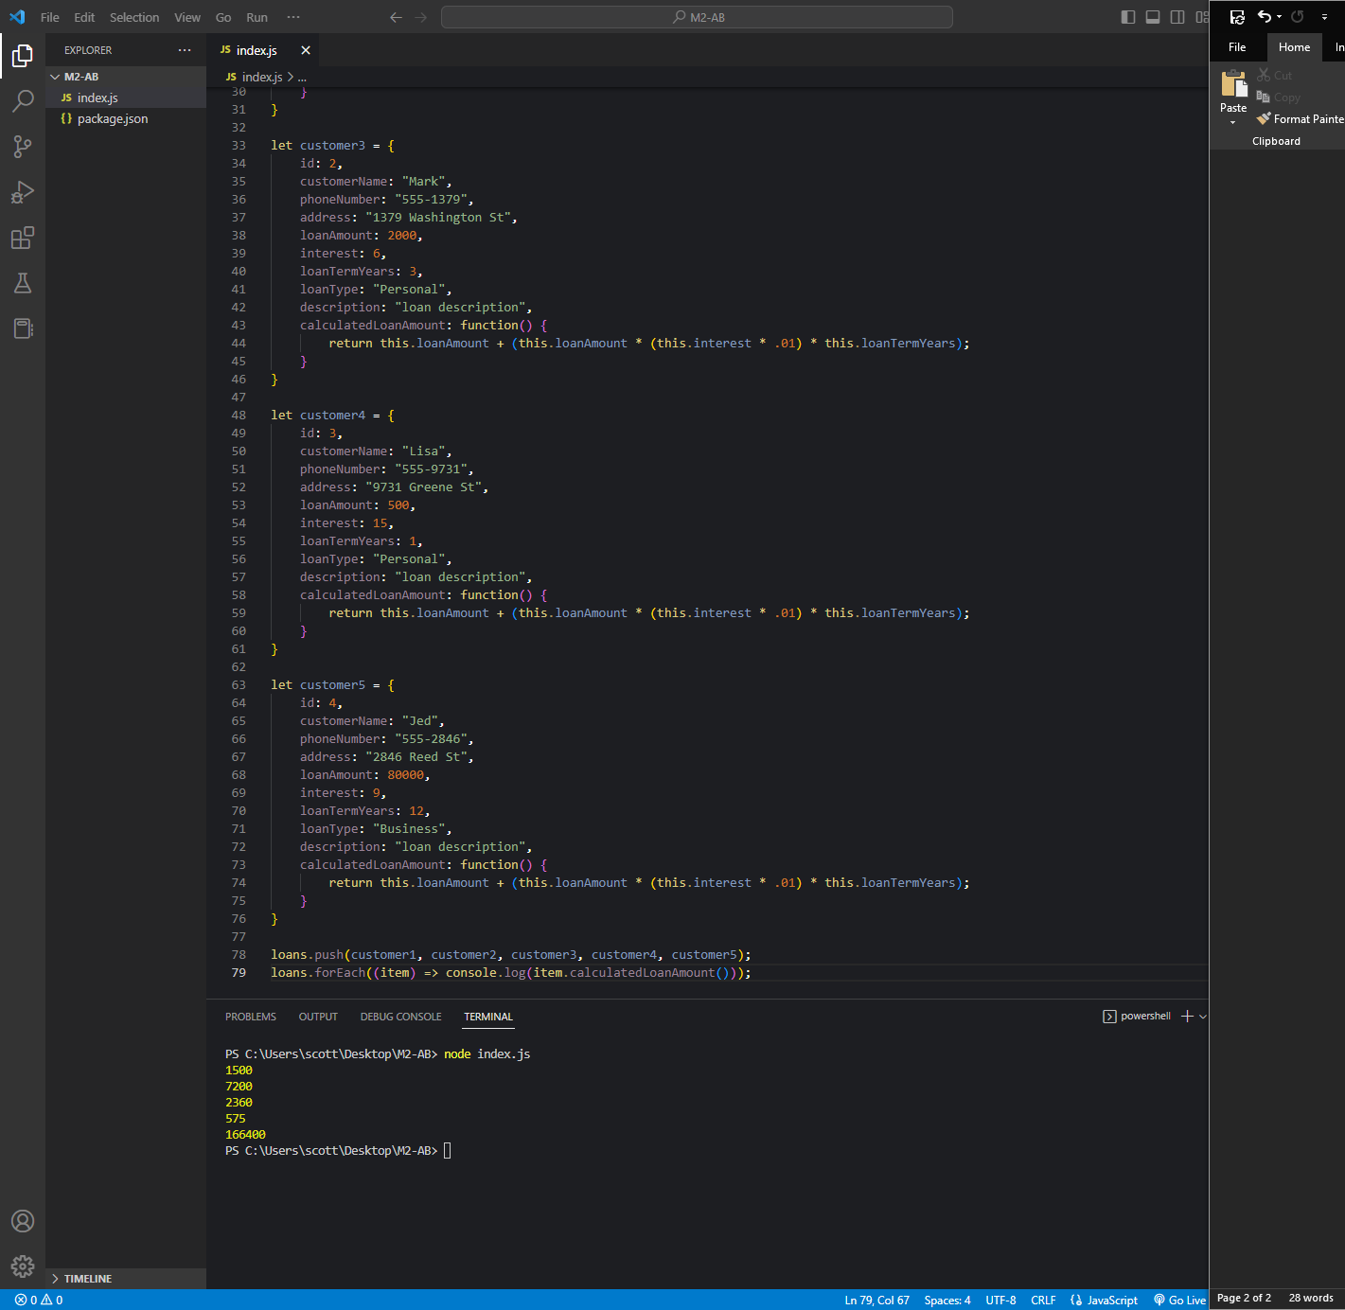*

*Code:*

let loans = [];

let customer1 = {

    id: 0,

    customerName: "John",

    phoneNumber: "555-1234",

    address: "1234 Elm St",

    loanAmount: 1000,

    interest: 10,

    loanTermYears: 5,

    loanType: "Personal",

    description: "loan description",

    calculatedLoanAmount: function() {

        return this.loanAmount + (this.loanAmount \* (this.interest \* .01) \* this.loanTermYears);

    }

}

let customer2 = {

    id: 1,

    customerName: "Sarah",

    phoneNumber: "555-5678",

    address: "5678 Baker St",

    loanAmount: 4000,

    interest: 8,

    loanTermYears: 10,

    loanType: "Business",

    description: "loan description",

    calculatedLoanAmount: function() {

        return this.loanAmount + (this.loanAmount \* (this.interest \* .01) \* this.loanTermYears);

    }

}

let customer3 = {

    id: 2,

    customerName: "Mark",

    phoneNumber: "555-1379",

    address: "1379 Washington St",

    loanAmount: 2000,

    interest: 6,

    loanTermYears: 3,

    loanType: "Personal",

    description: "loan description",

    calculatedLoanAmount: function() {

        return this.loanAmount + (this.loanAmount \* (this.interest \* .01) \* this.loanTermYears);

    }

}

let customer4 = {

    id: 3,

    customerName: "Lisa",

    phoneNumber: "555-9731",

    address: "9731 Greene St",

    loanAmount: 500,

    interest: 15,

    loanTermYears: 1,

    loanType: "Personal",

    description: "loan description",

    calculatedLoanAmount: function() {

        return this.loanAmount + (this.loanAmount \* (this.interest \* .01) \* this.loanTermYears);

    }

}

let customer5 = {

    id: 4,

    customerName: "Jed",

    phoneNumber: "555-2846",

    address: "2846 Reed St",

    loanAmount: 80000,

    interest: 9,

    loanTermYears: 12,

    loanType: "Business",

    description: "loan description",

    calculatedLoanAmount: function() {

        return this.loanAmount + (this.loanAmount \* (this.interest \* .01) \* this.loanTermYears);

    }

}

loans.push(customer1, customer2, customer3, customer4, customer5);

loans.forEach((item) => console.log(item.calculatedLoanAmount()));